**Practical No 7**

**Description:**

Selenium IDE (Integrated Development Environment) is the simplest tool in the Selenium Suite. It is a Firefox add-on that creates tests very quickly through its record-and-playback functionality. This feature is similar to that of QTP. It is effortless to install and easy to learn.

**Aim: To Recording and Replaying Test Cases, Creating and Running Test Suite.**

**Theory:**

**Test Case:** A test case is a document, which has a set of test data, preconditions, expected results and postconditions, developed for a particular test scenario in order to verify compliance against a specific requirement. Test Case acts as the starting point for the test execution, and after applying a set of input values, the application has a definitive outcome and leaves the system at some end point or also known as execution post condition. Test case parameter consists of: Test Case ID, Test Scenario, Test Case Description, Test Steps, Prerequisite, Test Data, Expected Result, Actual Result and Comments.

**Test Suite:** Test suite is a container that has a set of tests which helps testers in executing and reporting the test execution status. It can take any of the three states namely Active, InProgress and completed. A Test case can be added to multiple test suites and test plans. After creating a test plan, test suites are created which in turn can have any number of tests. Test suites are created based on the cycle or based on the scope. It can contain any type of tests, viz - functional or Non-Functional.

**Create a Test Case for Registration Page of PHP travels**

**Step 1:** Lunch Edge and then open Selenium IDE from toolbar menu.

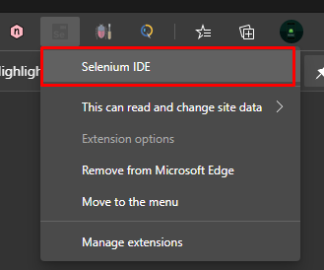

**Step 2:** Once it open, create a new project and name it as ‘Register Demo’.

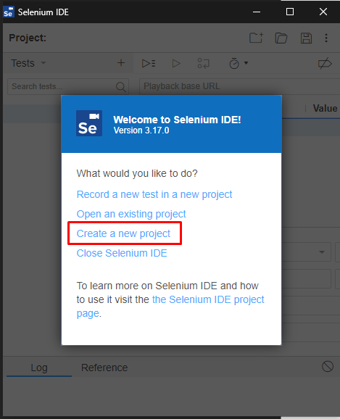 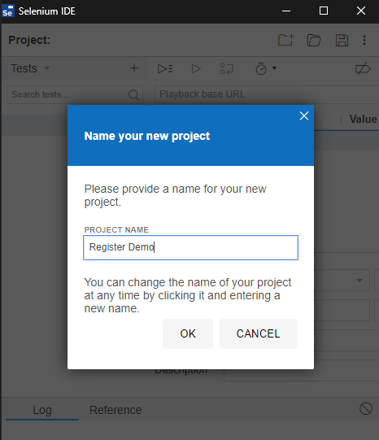

**Step 3:** Enter the URL of PHP travels website to create a test case in URL tab. Then record a test case for registration by selecting the REC button on top right corner of selenium ide. Once the recording is started, we have to register the account in that website and all the steps will be recorded.

**Step 4:** After we finish registration, stop the recording by clicking stop button on top right corner and then re-run the case to check if all the test has been executed or not. If the test has been executed then we will get the output test has been execute else we will get error in the output.

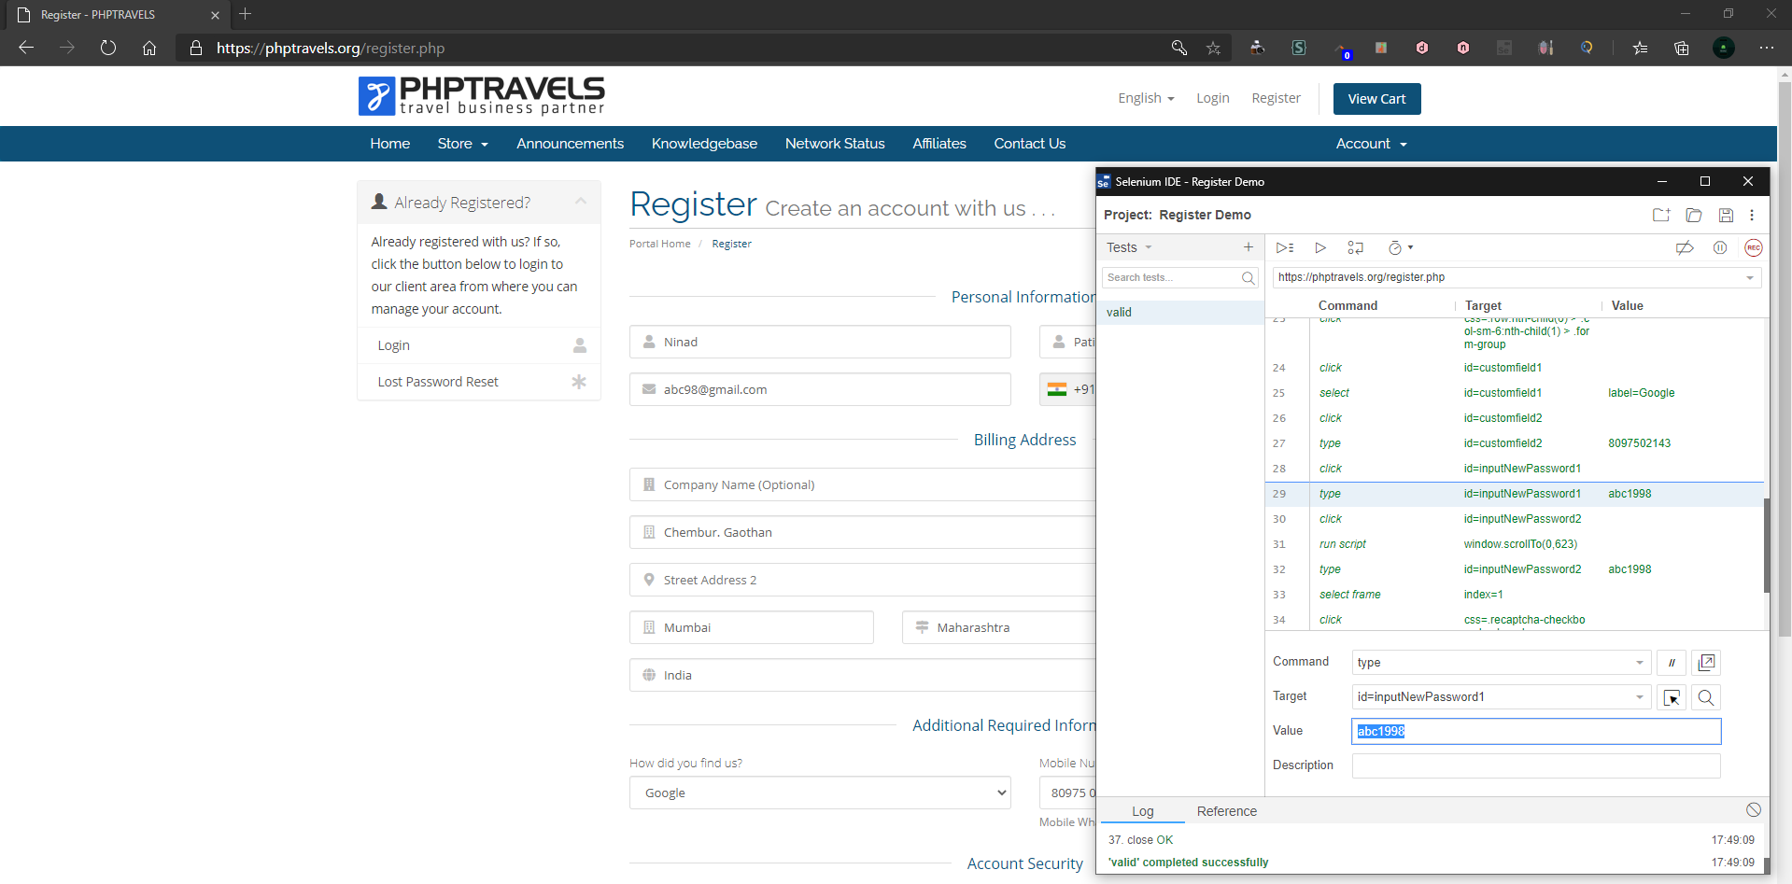

// Generated by Selenium IDE

import org.junit.Test;

import org.junit.Before;

import org.junit.After;

import static org.junit.Assert.*;

import static org.hamcrest.CoreMatchers.is;

import static org.hamcrest.core.IsNot.not;

import org.openqa.selenium.By;

import org.openqa.selenium.WebDriver;

import org.openqa.selenium.firefox.FirefoxDriver;

import org.openqa.selenium.chrome.ChromeDriver;

import org.openqa.selenium.remote.RemoteWebDriver;

import org.openqa.selenium.remote.DesiredCapabilities;

import org.openqa.selenium.Dimension;

import org.openqa.selenium.WebElement;

import org.openqa.selenium.interactions.Actions;

import org.openqa.selenium.support.ui.ExpectedConditions;

import org.openqa.selenium.support.ui.WebDriverWait;

import org.openqa.selenium.JavascriptExecutor;

import org.openqa.selenium.Alert;

import org.openqa.selenium.Keys;

import java.util.*;

import java.net.MalformedURLException;

import java.net.URL;

public class ValidTest {

private WebDriver driver;

private Map<String, Object> vars;

JavascriptExecutor js;

@Before

public void setUp() {

driver = new ChromeDriver();

js = (JavascriptExecutor) driver;

vars = new HashMap<String, Object>();

}

@After

public void tearDown() {

driver.quit();

}

@Test

public void valid() {

driver.get("https://phptravels.org/register.php");

driver.manage().window().setSize(new Dimension(974, 1040));

driver.findElement(By.id("inputFirstName")).sendKeys("Ninad");

driver.findElement(By.id("inputLastName")).click();

driver.findElement(By.id("inputLastName")).sendKeys("Patil");

driver.findElement(By.id("inputEmail")).click();

driver.findElement(By.id("inputEmail")).sendKeys("abc98@gmail.com");

driver.findElement(By.cssSelector(".selected-flag > .iti-flag")).click();

driver.findElement(By.cssSelector(".highlight > .country-name")).click();

driver.findElement(By.id("inputPhone")).click();

driver.findElement(By.id("inputPhone")).sendKeys("8097502143");

driver.findElement(By.id("inputAddress1")).click();

driver.findElement(By.id("inputAddress1")).sendKeys("Chembur. Gaothan");

driver.findElement(By.id("inputCity")).click();

driver.findElement(By.id("inputCity")).sendKeys("Mumbai");

driver.findElement(By.id("stateinput")).click();

driver.findElement(By.id("stateinput")).sendKeys("Maharashtra");

driver.findElement(By.id("inputPostcode")).click();

driver.findElement(By.id("inputPostcode")).sendKeys("400071");

driver.findElement(By.id("inputCountry")).click();

{ WebElement dropdown = driver.findElement(By.id("inputCountry"));

dropdown.findElement(By.xpath("//option[. = 'India']")).click(); }

driver.findElement(By.id("inputCountry")).click();

driver.findElement(By.cssSelector(".row:nth-child(6) > .col-sm-6:nth-child(1) > .form-group")).click();

driver.findElement(By.id("customfield1")).click();

{

WebElement dropdown = driver.findElement(By.id("customfield1"));

dropdown.findElement(By.xpath("//option[. = 'Google']")).click();

}

driver.findElement(By.id("customfield2")).click();

driver.findElement(By.id("customfield2")).sendKeys("8097502143");

driver.findElement(By.id("inputNewPassword1")).click();

driver.findElement(By.id("inputNewPassword1")).sendKeys("abc1998");

driver.findElement(By.id("inputNewPassword2")).click();

js.executeScript("window.scrollTo(0,623)");

driver.findElement(By.id("inputNewPassword2")).sendKeys("abc1998");

driver.switchTo().frame(1);

driver.findElement(By.cssSelector(".recaptcha-checkbox-checkmark")).click();

driver.switchTo().defaultContent();

driver.findElement(By.cssSelector(".btn-large")).click();

driver.close();

}

}

**Create a test suite which contains valid & invalid Testcases for Login page of PHP travels**

**VALID LOGIN:**

Test Data:

Email Address: abc98@gmail.com

Password: abc1998

**Step 1:** Lunch Edge and then open Selenium IDE from toolbar menu.



**Step 2:** Once it open, create a new project and name it as ‘Login Demo’.

 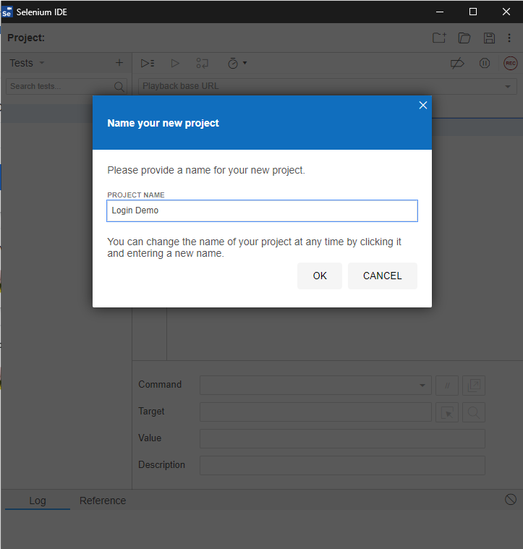

**Step 3:** Enter the URL of PHP travels website to create a test case in URL tab. Then record a test case for login by selecting the REC button on top right corner of selenium ide. Once the recording is started, we have to login the account in that website and all the steps will be recorded.

**Step 4:** Once it logged in, stop the recording by clicking stop button on top right corner and then re-run the case to check if all the test has been executed or not. If the test has been executed then we will get the output test has been execute else we will get error in the output.

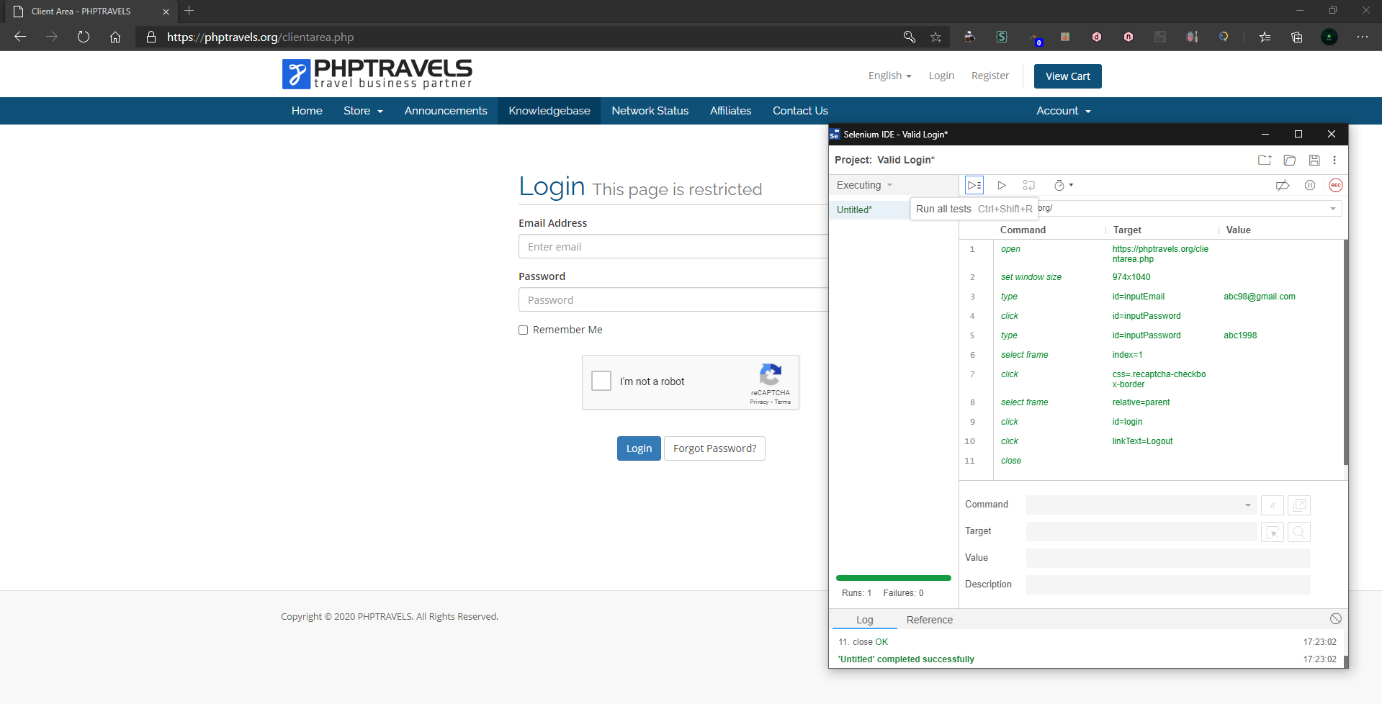

// Generated by Selenium IDE

import org.junit.Test;

import org.junit.Before;

import org.junit.After;

import static org.junit.Assert.*;

import static org.hamcrest.CoreMatchers.is;

import static org.hamcrest.core.IsNot.not;

import org.openqa.selenium.By;

import org.openqa.selenium.WebDriver;

import org.openqa.selenium.firefox.FirefoxDriver;

import org.openqa.selenium.chrome.ChromeDriver;

import org.openqa.selenium.remote.RemoteWebDriver;

import org.openqa.selenium.remote.DesiredCapabilities;

import org.openqa.selenium.Dimension;

import org.openqa.selenium.WebElement;

import org.openqa.selenium.interactions.Actions;

import org.openqa.selenium.support.ui.ExpectedConditions;

import org.openqa.selenium.support.ui.WebDriverWait;

import org.openqa.selenium.JavascriptExecutor;

import org.openqa.selenium.Alert;

import org.openqa.selenium.Keys;

import java.util.*;

import java.net.MalformedURLException;

import java.net.URL;

public class ValidLoginTest {

private WebDriver driver;

private Map<String, Object> vars;

JavascriptExecutor js;

@Before

public void setUp() {

driver = new ChromeDriver();

js = (JavascriptExecutor) driver;

vars = new HashMap<String, Object>();

}

@After

public void tearDown() {

driver.quit();

}

@Test

public void validLogin() {

driver.get("https://phptravels.org/clientarea.php");

driver.manage().window().setSize(new Dimension(974, 1040));

driver.findElement(By.id("inputEmail")).sendKeys("abc98@gmail.com");

driver.findElement(By.id("inputPassword")).click();

driver.findElement(By.id("inputPassword")).sendKeys("abc1998");

driver.switchTo().frame(1);

driver.findElement(By.cssSelector(".recaptcha-checkbox-border")).click();

driver.switchTo().defaultContent();

driver.findElement(By.id("login")).click();

driver.findElement(By.linkText("Logout")).click();

driver.close();

}

}

**INVALID LOGIN:**

Invalid email address and valid password

Email Address: abc@gmail.com

Password: abc1998

Step 5: In this test we must insert invalid data either its valid email address / invalid password or invalid email address / valid password. Once it executed then we will get the test executed message.

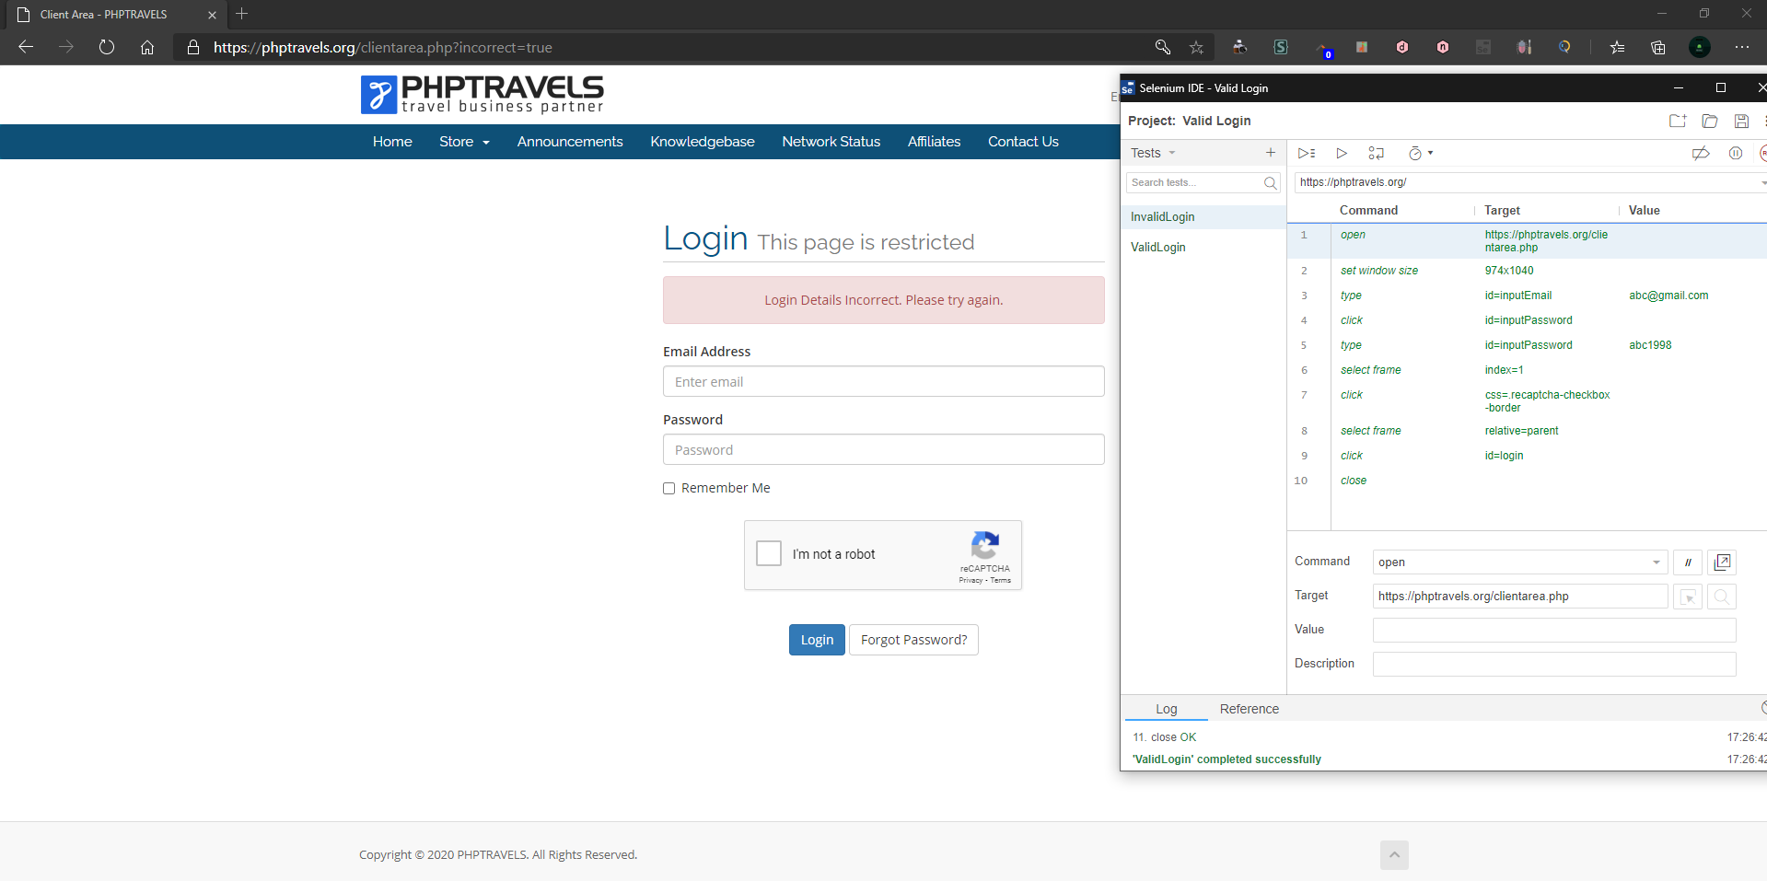

// Generated by Selenium IDE

import org.junit.Test;

import org.junit.Before;

import org.junit.After;

import static org.junit.Assert.*;

import static org.hamcrest.CoreMatchers.is;

import static org.hamcrest.core.IsNot.not;

import org.openqa.selenium.By;

import org.openqa.selenium.WebDriver;

import org.openqa.selenium.firefox.FirefoxDriver;

import org.openqa.selenium.chrome.ChromeDriver;

import org.openqa.selenium.remote.RemoteWebDriver;

import org.openqa.selenium.remote.DesiredCapabilities;

import org.openqa.selenium.Dimension;

import org.openqa.selenium.WebElement;

import org.openqa.selenium.interactions.Actions;

import org.openqa.selenium.support.ui.ExpectedConditions;

import org.openqa.selenium.support.ui.WebDriverWait;

import org.openqa.selenium.JavascriptExecutor;

import org.openqa.selenium.Alert;

import org.openqa.selenium.Keys;

import java.util.*;

import java.net.MalformedURLException;

import java.net.URL;

public class InvalidLoginTest {

private WebDriver driver;

private Map<String, Object> vars;

JavascriptExecutor js;

@Before

public void setUp() {

driver = new ChromeDriver();

js = (JavascriptExecutor) driver;

vars = new HashMap<String, Object>();

}

@After

public void tearDown() {

driver.quit();

}

@Test

public void invalidLogin() {

driver.get("https://phptravels.org/clientarea.php");

driver.manage().window().setSize(new Dimension(974, 1040));

driver.findElement(By.id("inputEmail")).sendKeys("abc@gmail.com");

driver.findElement(By.id("inputPassword")).click();

driver.findElement(By.id("inputPassword")).sendKeys("abc1998");

driver.switchTo().frame(1);

driver.findElement(By.cssSelector(".recaptcha-checkbox-border")).click();

driver.switchTo().defaultContent();

driver.findElement(By.id("login")).click();

driver.close();

}

}

**Conclusion: We have successfully recorded and replayed test cases, created and run test suite.**